**Transfer Files over Wi-Fi Between PCs / PC and Phone**

Wi-Fi file transfer has become a popular way of transferring files due to its speed and the fact that it doesn't require wired connections or external storage devices. It only requires a local area connection, and the computer needs to be connected to the local area network either through a LAN cable or a Wi-Fi adapter. Here, we’ll see a few simple methods to **transfer files via Wi-Fi**. The first part contains the process to transfer files from PC to PC over Wi-Fi, and the second part includes methods to transfer files from PC to phone over Wi-Fi.

**Part 1: Transfer Files from PC to PC over Wi-Fi**

**Method 1: Using Nearby Sharing on Windows 10/11**

The Nearby Sharing feature on Windows 10 and 11 allows users to transfer files via Wi-Fi from PC to PC connected to the same network.

Using Nearby sharing is easy, but it requires doing some settings before you can transfer files via Wi-Fi. The settings need to be done on both systems and are given below:

* + Open the “Settings” app and go to “System” settings.

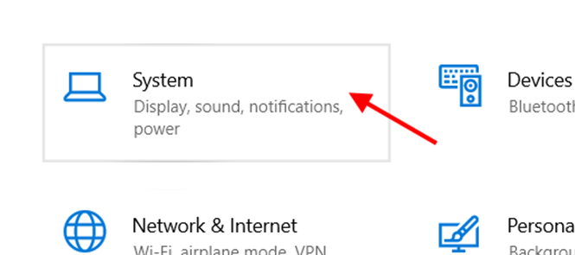

* + On the next window, click on “Shared Experience” and turn ON the “Nearby Sharing” option from the right-side panel.

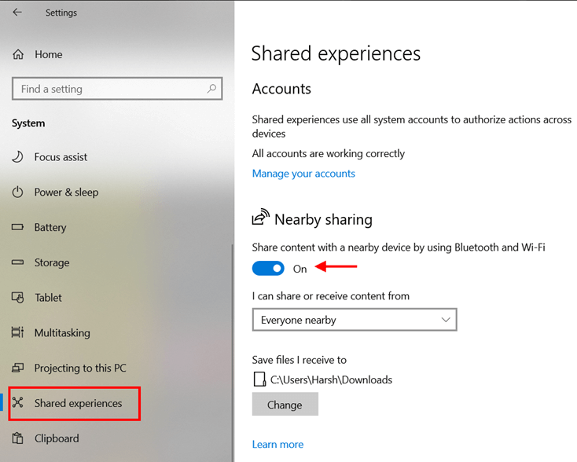

Select “Everyone nearby” from the dropdown menu just below the toggle button.

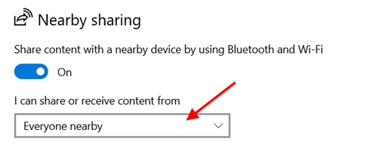

Now, select the location of saving received files from the option below the dropdown menu.

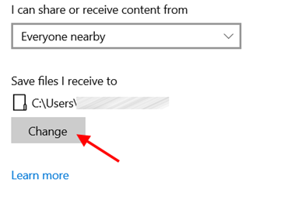

* + Now, scroll down some more on the same window and turn ON the “Share across devices” option. Then, select “Everyone nearby” from the dropdown menu just below it.

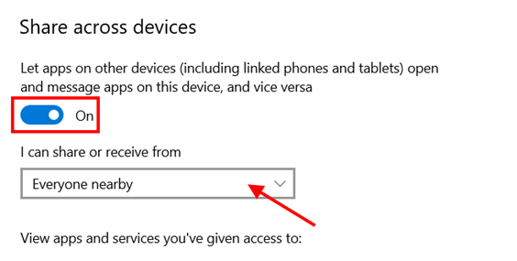

Now let’s see how to transfer files via Wi-Fi using Nearby sharing:

Steps:

* + On the PC from which you want to share something, go to the file location, and right-click on the file. Now, select the “Share” option.

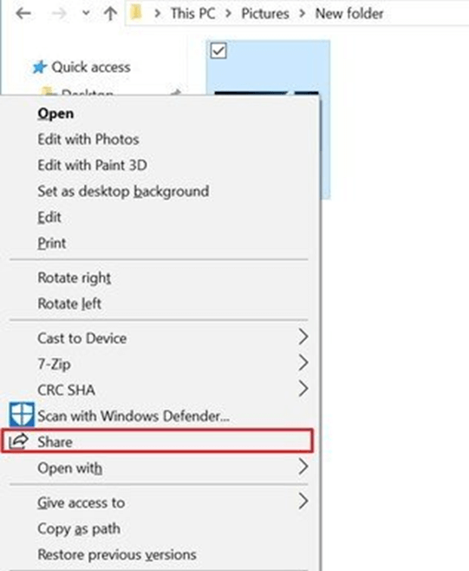

* + From the pop-up window, click on the PC icon of the recipient computer to transfer the file via Wi-Fi.

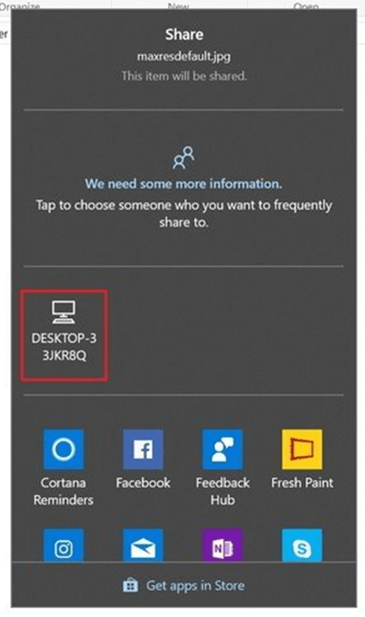

* + The recipient PC will ask for permission to “Save” or “Decline” the transfer. Click “Save” to start the transfer.

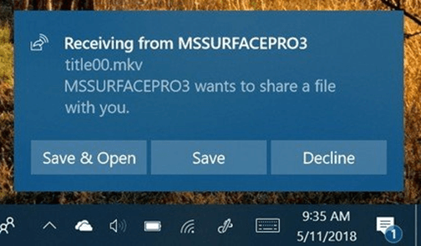

The file will be saved to the location you had set before.

**Method 2:** **Using File and Printer Sharing on Windows 7/XP**

Nearby sharing is a great feature; however, it isn’t available on older versions of Windows like 7 or XP. But there is a feature called File and Printer Sharing, which can transfer files via Wi-Fi from PC to PC.

Here also, some settings are required before using the file transfer. They are given below:

* + - Open the Control Panel and click on the “Network and Internet” option.
    - Select “Network and Sharing Center” and click on “Change advanced sharing settings” from the left panel.
    - In the “File and Printer Sharing” section of the Public Network, turn ON File and Printer Sharing and click “Save Changes.” (You can turn ON password-protected sharing from here so that no one other than the recipient can connect to your PC.)

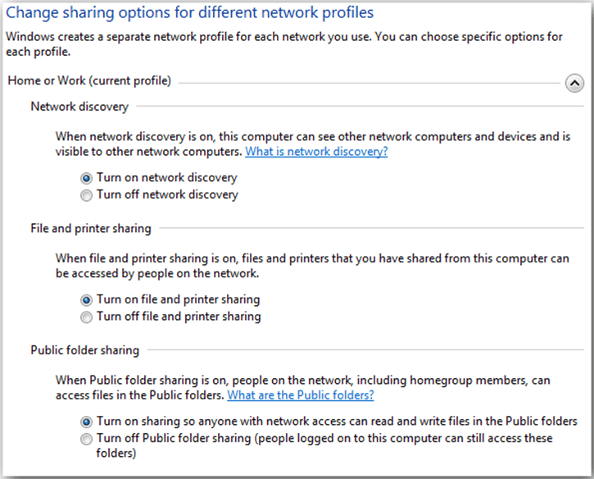

Now, you need to share files so that the recipient PC can access them. The steps to do this are as follows:

* + - Right-click on the folder you want to share, select the “Give Access to” option, and click on “Specific people.”
    - From the new pop-up window, select the recipient’s system from the list or choose “Everyone” from the dropdown menu.
    - Click on “Share” to start sharing the contents of that folder to another system on the same network. You can copy and paste anything you want to share inside that folder, and it’ll be accessible from the recipient’s computer.

**Part 2: Transfer Files from PC to Phone over Wi-Fi**

**Method 1: Using Wi-Fi File Transfer application**

Wi-Fi File Transfer is a free-to-use application that can be used to transfer files to a phone over Wi-Fi. First, you need to install the application on your Android phone. To install it, visit the Google Play Store and type “Wi-Fi File Transfer” in the search box. Click install and wait till the process is finished.

 Steps to transfer files to phone over Wi-Fi using Wi-Fi File Transfer app:

* + - Launch the application on your phone.

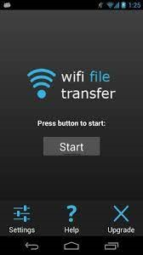

* + - (Optional) Go to the app’s “Settings” option and set an “Access Password” to make secure transfers on public networks.
    - On the main screen of the app, click on “Start.”
    - Now, type the web address or URL shown on the app screen on a desktop browser window and press “Enter.”

        A web page will open where you can see all the folders and files in your phone’s storage.

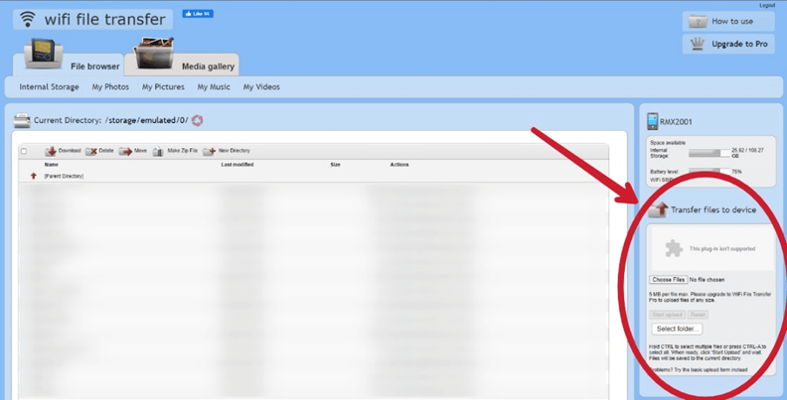

        Now, locate the “Transfer Files to Device” section on the right, as shown above.

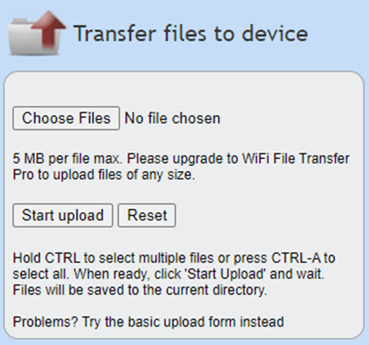

* Click on the “Choose Files” option and select the items you want to transfer over Wi-Fi. Also, you can select the folder where you want to save the items by navigating to it from the left side phone storage navigator.
* Now, click on “Start Upload” and let it finish. Then, you’ll be able to access the stuff from your phone.

**Conclusion**

Wi-Fi transfer is best in the case of PC to PC file transfer. For PC to phone file transfer, Wi-Fi sharing can be used if there are no USB cables available or if the file is tiny. But it is always recommended to perform data transfers via wires to avoid any data loss or theft. Also, a wire transfer is the fastest method to transfer large files, and it provides more security than Wi-Fi.